

**KABARAK UNIVERSITY  
SCHOOL OF SCIENCE, ENGINEERING, AND TECHNOLOGY**

**DEPARTMENT OF COMPUTER SCIENCE & IT**

**DESIGN AND DEVELOPMENT OF AN AI PREDICTIVE MODELLING FOR CAR PRICING USING PUBLIC DATASETS**

BRIAN EZEKIEL KATHI NJERI

INTE/MG/1681/09/22

*Project Proposal Submitted to the School of Science, Engineering and Technology  
in Partial Fulfillment of the Requirements for the Award of the Degree of  
Bachelor of Science in Information Technology of Kabarak University.*

*Copyright ©2025*

# DECLARATION

This project proposal is my original work and has not been submitted for academic credit in any other institution.

NAME: **BRIAN EZEKIEL KATHI NJERI**  REG. NO: **INTE/MG/1681/09/22**

Signature: …………………………………… Date: ……………………………………...

**SUPERVISOR**

**EVANS CHESANG**

This project proposal has been submitted for examination with my approval as the assigned university supervisor

Signature: …………………………………… Date: ………………………………….

# ACKNOWLEDGEMENTS

I would like to thank everyone who had contributed to the successful completion of this project. I would like to express my gratitude to my research supervisor, Mr. Evans Chesang for his invaluable advice, guidance and his enormous patience throughout the development of the research. In addition, I would also like to express my gratitude to my loving parents and friends who had helped and given me encourage

# ABSTRACT

The rapid evolution of Artificial Intelligence (AI) and Machine Learning (ML) technologies has provided a pathway for solving complex problems across various sectors. One such area is the automobile industry, where predicting the selling price of used cars has become increasingly crucial for both buyers and sellers. Traditionally, car valuation has depended heavily on human judgment, often leading to inaccurate pricing and lack of transparency. This project aims to address these challenges by developing a Machine Learning-based Car Price Prediction System that can estimate the fair market value of a car based on key attributes such as make, model, and mileage, year of manufacture, fuel type, transmission, and engine size/type. The inability to correctly estimate car prices leads to either overpricing, which discourages buyers, or underpricing, which causes losses to sellers. This issue is especially common in developing economies, where car pricing lacks standardization and access to professional appraisals is limited. The proposed system, will be trained on a Kaggle-sourced dataset, is designed to automate and optimize the pricing process by learning from historical data and recognizing patterns that influence car prices. The use of real-time prediction models provides a reliable, data-driven foundation for decision-making in vehicle transactions. The system will incorporate several machine learning models including Random Forest Regressor, and XGBoost, with model selection based on performance metrics such as RMSE and R² score. The system is developed using Python for the backend and integrated with a web-based interface for usability. Feature engineering and data preprocessing steps such as handling missing values, encoding categorical variables, and normalization are employed to enhance model accuracy. The proposed solution is not only cost-effective but also scalable and user-friendly, aiming to empower individual car owners, dealerships, and online car marketplaces. By providing a predictive system that reduces human bias and improves pricing transparency, the project contributes toward a more efficient and trustworthy used-car market. Agile methodology is adopted for development and iteration, ensuring flexibility and continuous improvement of the system. Once fully implemented, the system is expected to streamline the car buying and selling process, increase market fairness, and offer data-backed insights into car valuation.

**TABLE OF CONTENTS**

DECLARATION 2

ACKNOWLEDGEMENTS 3

ABSTRACT 4

LIST OF ABBREVIATIONS 8

LIST OF FIGURES 10

CHAPTER ONE 11

INTRODUCTION 11

1.1 Introduction 11

1.2 Background of the study 11

1.3 Statement of the Problem 12

1.4 Objectives of the Study 12

1.4.1 General Objective 12

1.4.2 Specific Objectives 12

1.5 Research Questions 13

1.6 Significance of the Project 13

1.6.1 To Individual Sellers and Buyers 13

1.6.2 To Car Dealerships 13

1.6.3 To Online Car Marketplaces 13

1.6.4 To the Automotive Industry 13

1.7 Scope of the Project 13

1.8 Justification of the project 14

1.9 Existing Systems 14

1.10 Proposed System 15

1.11 Feasibility Study 15

1.11.1 Operational Feasibility 15

1.11.2 Economic Feasibility 16

1.11.3 Technical Feasibility 16

1.11.4 Schedule Feasibility 16

CHAPTER TWO 17

LITERATURE REVIEW 17

2.1 Introduction 17

2.2 Review of Objective I 17

2.3 Review of Objective II 18

2.4 Review of Objective III 18

2.5 Conceptual framework 19

2.5.1 Independent Variables 19

2.5.2 Moderating Variables 20

2.5.3 Dependent Variable 20

CHAPTER THREE 21

METHODOLOGY 21

3.1 Introduction 21

3.2 Research Design 21

3.3 Software Development Life Cycle (SDLC) 22

3.3.1 SDLC Phases 22

3.3.2 Overview of SDLC Methodologies 24

3.2.3 Agile Methodologies 26

3.4 Selection of Methodology 28

3.5 Justification of the Selected Methodology 29

3.6 Research Instrument 30

3.7 System Analysis and Design 30

3.7.1 System Analysis 31

3.8 Research Ethics 38

3.8.1 Privacy and Confidentiality 38

3.8.2 Data Protection 38

3.9.3 Avoidance of Plagiarism 38

3.9.4 Compliance with Institutional Guidelines 38

CHAPTER FOUR 39

SYSTEM IMPLEMENTATION AND DEPLOYMENT 39

4.1 Introduction 39

4.2 Development Environment Setup 39

4.2.1 Software Tools and Environments 40

4.2.2 Development Environment Configuration 44

4.3 Implementation Steps 46

4.3.1 Step-by-Step Implementation Plan 46

4.3.2 Timeline and Milestones 53

4.3.3 Coding Standards and Practices 53

d. Quality Assurance 54

4.4 Testing and Quality Assurance 54

4.4.1 Testing Strategy 54

4.4.2 Quality Assurance (QA) 55

4.5 Deployment Plan 56

4.5.1 Deployment Strategy 56

4.5.2 Data Migration and Configuration 57

4.6 Go-Live Plan 58

4.6.1 Transition to Production 58

4.7 Maintenance and Support 58

4.7.1 Maintenance Plan 58

4.7.2 User Support 59

4.8 Conclusion and Future Work 59

REFERENCES 60

APPENDICES 61

Appendix 1: Sample System Interface Screenshots 61

Appendix 2: Model Training and Evaluation Code Snippets 62

# LIST OF ABBREVIATIONS

|  |  |
| --- | --- |
| AI | Artificial Intelligence |
| ML | Machine Learning |
| DL | Deep Learning |
| CSV | Comma Separated Values |
| API | Application Programming Interface |
| UI | User Interface |
| UX | User Experience |
| DFD | Data Flow Diagram |
| SDLC | Software Development Life Cycle |
| UTAUT | Unified Theory of Acceptance and Use of Technology |
| TAM | Technology Acceptance Model |
| CRUD | Create, Read, Update, Delete |
| IDE | Integrated Development Environment |
| HTML | Hypertext Markup Language |
| CSS | Cascading Style Sheets |
| JS | JavaScript |
| DB | Database |
| RF | Random Forest |
| XGBoost | Extreme Gradient Boosting |
| JSON | JavaScript Object Notation |
| HTTP | Hypertext Transfer Protocol |
| HTTPS | Hypertext Transfer Protocol Secure |
| MVC | Model View Controller |
| REST | Representational State Transfer |
| UI/UX | User Interface/User Experience |
| SRS | Software Requirements Specification |
| IP | Internet Protocol |
| ML Model | Machine Learning Model |
| ETL | Extract, Transform, Load |
| PIP | Package Installer for Python |
| N/A | Not Applicable |
| CI/CD | Continuous Integration / Continuous Deployment |
| RAM | Random Access Memory |
| CPU | Central Processing Unit |
| OSS | Open Source Software |
| SaaS | Software as a Service |
| LAN | Local Area Network |
| WAN | Wide Area Network |
| GCP | Google Cloud Platform |
| AWS | Amazon Web Services |
| MVC | Model-View-Controller |
| UXD | User Experience Design |
| FOSS | Free and Open Source Software |

# LIST OF FIGURES

Figure 1 Conceptual framework 20

Figure 2 Agile methodology 27

Figure 3iterations diagram 29

Figure 4 System Architecture 32

Figure 5 Context diagram 33

Figure 6 Sequence diagram 34

Figure 7 class diagram 35

Figure 8 Activity diagram 36

Figure 9 data flow diagram 37

Figure 10 notebook 41

Figure 11 Flask Flamework in Python 42

Figure 12 HTML,CSS and Javascript files 43

Figure 13 Github and Github contro extensions 44

Figure 14 Data processing code 46

Figure 15 How the model was developed 47

Figure 16 Backend code 48

Figure 17Ui landing page 48

Figure 18 Ui data input page 49

Figure 19 UI Input page 49

Figure 20The buttons for the Prediction 50

Figure 21UI output page 50

Figure 22 Ui after the predictions 51

Figure 23 Addictional recommedation from the system 51

Figure 24 Intergration of the System 52

Figure 25 deployed Locally 57

# 

# CHAPTER ONE

# INTRODUCTION

## Introduction

This chapter contains the background of the study, the problem statement, purpose of the study, objectives, research questions, justification of the system, significance of the study, scope of the study, limitations and delimitations, assumptions of the study, and definition of terms. It introduces the development of a Machine Learning-based car price prediction system designed to address the challenge of inaccurate vehicle pricing in the used car market. The system uses historical data to estimate car prices more accurately and objectively, helping both buyers and sellers make informed decisions.

## Background of the study

In recent years, the automobile industry has witnessed a significant shift toward digital transformation, especially in how vehicles are bought and sold. This aligns with findings by Jain et al. (2021), who highlight the growing role of digital tools in enhancing transaction efficiency. One key challenge in the used car market is determining a fair and accurate price for second-hand vehicles. Patil and Deshmukh (2020) note that traditional methods often lack consistency due to subjective evaluations. Traditionally, car valuation has relied heavily on individual judgment, manual inspection, or dealership estimates, which are often subjective and inconsistent. This lack of standardized pricing creates room for financial loss, customer dissatisfaction, and delayed transactions (Singh & Sharma, 2022). With the availability of large-scale automotive data and the advancement of Artificial Intelligence (AI) and Machine Learning (ML) technologies, it is now possible to predict car prices based on patterns found in historical data. Studies such as Zhou and Fan (2020) have shown that ML models can capture relationships among variables like brand, mileage, and engine size to make accurate predictions. Various factors such as car brand, model, manufacturing year, fuel type, mileage, engine size, and transmission type influence a vehicle's resale value. By training ML models on such features, it becomes possible to build a predictive system that estimates accurate car prices with minimal human intervention. The use of machine learning not only increases pricing accuracy but also saves time, reduces negotiation gaps, and fosters trust among buyers and sellers (Chakraborty et al., 2022). For this reason, the current project focuses on developing a car price prediction system using a Kaggle dataset and Python-based ML tools to provide reliable, data-driven car valuation insights. Similar models have been effectively implemented to assist car owners, dealers, and online platforms in making informed pricing decisions (Rahman & Arif, 2020).

## 1.3 Statement of the Problem

Many individuals and dealerships face difficulties in accurately determining the value of used cars. Traditional pricing methods are often based on guesswork or manual evaluation, which leads to overpricing or underpricing. This results in loss of potential buyers, financial losses, and delays in transactions. Additionally, this system will provide real-time, data-driven price estimates based on key vehicle features.

This project seeks to address these issues by developing a Machine Learning-based car price prediction system that can automatically analyze relevant data and predict a fair market value. The system will reduce human error, increase pricing transparency, and assist users in making informed decisions when buying or selling vehicles.

## ****1.4 Objectives of the Study****

### ****1.4.1 General Objective****

The main objective of this study is to develop a Machine Learning-based car price prediction system that estimates the fair market value of used vehicles based on key features such as brand, model, mileage, year, fuel type, and engine size.

### ****1.4.2 Specific Objectives****

1. **To identify the key factors that most influence the predicted price of a used car in the developed system.**
2. To Design and development of an AI Predictive Modelling for Car Pricing Using Public Datasets
3. To test the performance of the developed predictive model by comparing its accuracy, speed, and resource usage with standard machine learning models.

## 1.5 Research Questions

1. What key factors most influence the predicted price of a used car in the developed system?
2. How can a machine learning-based predictive model be effectively designed and developed using public datasets to estimate used car prices accurately?
3. How does the performance of the developed predictive model compare to standard machine learning models in terms of accuracy, processing speed, and resource usage?

## ****1.6 Significance of the Project****

This project will be of value to individual car sellers and buyers, car dealerships, online marketplaces, and the automotive industry as a whole.

### ****1.6.1 To Individual Sellers and Buyers****

The system will help users get fair and accurate car price estimates, enabling informed decision-making. Sellers will avoid undervaluing their vehicles, while buyers will avoid being overcharged.

### ****1.6.2 To Car Dealerships****

Dealerships will benefit from consistent and data-driven pricing, which enhances customer trust and improves inventory turnover by offering competitive prices.

### ****1.6.3 To Online Car Marketplaces****

The system can be integrated into digital platforms to automate price suggestions, improving user experience and reducing pricing disputes.

### ****1.6.4 To the Automotive Industry****

By promoting standardized pricing, the system enhances transparency and efficiency in the used car market. This may contribute to higher customer satisfaction and a more stable resale market.

## 1.7 Scope of the Project

The study focuses on developing a Machine Learning-based system that predicts the prices of used cars to enhance transparency and reduce pricing inconsistencies in the automotive market. The main aim is to help car buyers and sellers make informed decisions by providing accurate and data-driven price estimates based on various vehicle features such as brand, model, mileage, year of manufacture, and fuel type.

In general, this proposed system addresses the problem of inaccurate car valuations and inefficient traditional pricing methods. The estimated time for the project is about 3 to 4 months, during which we will design, train, and test the model, and build a simple interface for user interaction. The system will also serve as a demonstration of how AI and machine learning technologies can be applied practically in the automotive industry.

Having set the foundation, the achievements expected include: reducing human error in car pricing, improving market fairness, saving time in valuation processes, and promoting trust between buyers and sellers. Ultimately, this will contribute to a more efficient and reliable used car market.

## 1.8 Justification of the project

This project intends to solve issues that arise from inaccurate and inconsistent car pricing in the used vehicle market. It uses Machine Learning technology to ensure that car prices are estimated based on actual data rather than human judgment, which is often biased or unreliable. This helps in reducing the financial losses that may occur due to overpricing or underpricing of vehicles.

The system also minimizes the time and effort required in the manual valuation process, making it more efficient for both individual sellers and dealerships. It ensures that pricing is done fairly, based on the exact features of each car, avoiding general assumptions. The project contributes to the development of a more transparent, trustworthy, and efficient automobile marketplace by using technology to improve the accuracy of car pricing.

## 1.9 Existing Systems

There is no existing automated system currently in place for predicting car prices. Most car buyers and sellers rely on personal judgment, online classifieds, or manual estimations to determine the value of used vehicles. These traditional methods are often inaccurate and inconsistent, leading to unfair pricing and mistrust between parties involved in the transaction.

In many cases, sellers overvalue their cars while buyers undervalue them, resulting in prolonged negotiations or failed deals. Additionally, car dealerships often use generalized pricing strategies that may not reflect the specific condition or features of individual vehicles. This manual process wastes time and resources and does not guarantee reliable outcomes. A data-driven system is therefore necessary to address these gaps and improve price accuracy in the used car market.

## 1.10 Proposed System

The proposed system is a Machine Learning-based car price prediction model designed to address the limitations of the current manual valuation methods. The system will make it possible to generate accurate and consistent car price estimates based on key features such as brand, model, mileage, year of manufacture, fuel type, and transmission.

This will be achieved by training ML algorithms on historical data to identify patterns that influence car pricing. The system will allow users to input car details and receive an estimated market value instantly, with little to no human intervention. By doing so, the system aims to minimize pricing errors, reduce negotiation time, and ensure fairness in transactions. It also promotes transparency and trust in the used car market.

## ****1.11 Feasibility Study****

The feasibility study looks at the viability of the proposed system to serve its intended purpose; to provide value that current manual methods do not offer. It also assesses whether there is enough technical capacity to implement the system, evaluates the estimated cost of development, and determines whether the system can be completed within the set time frame.

### ****1.11.1 Operational Feasibility****

After analyzing the current methods used in the secondhand car market, it became clear that most car pricing is done manually, either by estimation or through inconsistent comparisons. This process is often unreliable and varies greatly between sellers and platforms. Additionally, many buyers do not have the knowledge or tools to verify whether a car's listed price reflects its true market value. This inconsistency and lack of structure highlight the need for a system that provides objective, data-driven price predictions, which our proposed system aims to fulfill.

### ****1.11.2 Economic Feasibility****

The proposed system is highly cost-effective. It removes the need to hire professional car valuers or rely on costly pricing software subscriptions. Since it is based on open-source tools and a free dataset, the system will be inexpensive to develop and maintain. Moreover, it prevents unnecessary financial losses due to incorrect valuations and saves time in negotiations and pricing research. This leads to a more efficient marketplace and reduced overheads for both individual sellers and car dealerships.

### ****1.11.3 Technical Feasibility****

I possess the necessary technical skills in Machine Learning, Python programming, and data preprocessing to successfully implement this system. I have experience working with essential tools such as Scikit-learn, Pandas, and data visualization libraries, which are crucial for building and deploying a reliable predictive model. The technologies required for this system are readily accessible and align well with my skill set.

### ****1.11.4 Schedule Feasibility****

Time is a key factor in the success of any project. The car price prediction system is scheduled to be completed within 3 to 4 months. This time frame includes phases for data cleaning, model training and evaluation, user interface development, and system testing. With a clear roadmap and milestones in place, the project is expected to be completed within the allocated period.

# CHAPTER TWO

# LITERATURE REVIEW

## 2.1 Introduction

This chapter presents a wide range of literature review from previous studies, focusing primarily on the development and application of Machine Learning (ML) in car price prediction systems. It explores how predictive modeling has been used in the automotive industry to estimate the value of used vehicles and addresses the challenges of manual car valuation, such as pricing inconsistencies and human bias.

The review highlights scholarly projects, academic research, and real-world implementations that relate to this proposed system. It examines key concepts, models, and tools used in similar studies to provide a solid theoretical and practical foundation for the current project. Special attention is given to how various ML algorithms, such as Random Forest and XGBoost, have been applied to learn from historical data and predict outcomes based on important vehicle features.

The chapter is organized into the following key areas: A review of theoretical literature surrounding predictive analytics and car valuation, Adoption theories informing the study, the conceptual framework guiding the research, Identification of the research gap, A summary of the reviewed literature

## 2.2 Review of Objective I

Objective: To identify key factors influencing used car price predictions

Understanding which factors most influence by car prices is essential for building accurate predictive models. Research highlights several key attributes such as mileage, brand, model, engine size/type, fuel type, and transmission type as primary determinants (Kumar & Garg, 2021). These features often reflect the car’s wear, performance, and market appeal. Studies by Jain et al. (2020) and Patel & Shah (2019) show that mileage and year of manufacture are among the most predictive features due to their direct link to depreciation. Additionally, brand reputation and vehicle condition significantly impact a car’s resale value. Machine learning models like Random Forest and XGBoost help identify these factors by ranking feature importance during training. This ensures that only relevant inputs are used in prediction, improving accuracy and reliability (Zhou et al., 2020).

## 2.3 Review of Objective II

Objective: To Design and development of an AI Predictive Modelling for Car Pricing Using Public Datasets

The primary objective of this project is to design and develop an AI-based predictive modeling system that accurately estimates the market value of used vehicles by analyzing publicly available datasets. Traditional car valuation methods often rely on subjective human judgment or generalized estimates, which can result in inconsistent pricing and market inefficiencies. To address this challenge, the proposed system will utilize machine-learning algorithms trained on historical data to identify key patterns and relationships among vehicle attributes such as brand, model, mileage, engine size/type, fuel type, and year of manufacture. By leveraging these insights, the system will generate data-driven price predictions that enhance transparency, reduce human error, and support informed decision-making for both buyers and sellers. The solution aims to be cost-effective, scalable, and accessible, especially in environments where access to professional valuation services is limited.

## 2.4 Review of Objective III

Objective: To test the performance of the developed predictive model by comparing its accuracy, speed, and resource usage with standard machine learning models.

An essential objective of this project is to test the performance of the developed predictive model by benchmarking it against standard machine learning models. This involves a systematic evaluation of the model's accuracy, processing speed, and resource efficiency. By using performance metrics such as Root Mean Square Error (RMSE), R-squared (R²), and Mean Absolute Error (MAE), the study will assess how well the model predicts car prices in comparison to existing solutions. Additionally, the evaluation will include computational efficiency indicators—such as execution time and memory usage—to determine whether the model can be deployed effectively in environments with limited resources. This comparison is crucial to validate the practicality and robustness of the proposed system, particularly for real-time or mobile-based applications where resource constraints are significant.

## 2.5 Conceptual framework

A conceptual framework represents the researcher’s synthesis of existing literature and understanding of how various variables in the study interact to explain a phenomenon—in this case, the prediction of car prices using Machine Learning. It provides a structured view of the relationship between independent variables (input features of the model), moderating variables (factors influencing system adoption or performance), and the dependent variable (predicted car price). The framework serves as a “map” guiding the research investigation and system development.

### ****2.5.1 Independent Variables****

These primary features influence the predicted price of a car. They are used as inputs in the machine learning models and have a direct impact on the system’s output. These variables include:

* **Mileage (Kilometers Driven)**: The distance the car has been driven. Higher mileage often reduces a car’s resale value.
* **Fuel Type**: Whether the car runs on petrol, diesel, electric, or hybrid. Certain fuel types tend to retain more value.
* **Transmission Type**: The type of gearbox (manual or automatic) affects user preference and resale value.
* **Engine Capacity**: Larger engines may indicate higher performance but may also lead to higher fuel consumption.
* **Brand/Make**: Brand reputation and market value significantly influence a car’s resale price.
* **Model and Variant**: Specific models and trim levels within a brand can drastically affect price.

### ****2.5.2 Moderating Variables****

These are variables that may not directly affect the predicted price but can influence how the system is used or how accurately it performs in various contexts:

* **Data Quality**: The accuracy, completeness, and relevance of historical data impact model training and prediction accuracy.
* **User ICT Skills**: The ease of interacting with the system depends on how well users understand basic digital tools.
* **Model Interpretability**: Some models may provide better explanations and transparency to users, affecting trust and adoption.
* **Economic Conditions**: Inflation, fuel prices, and market demand can alter how users perceive value and system usefulness.
* **Internet/Platform Accessibility**: Availability of online platforms and system access can influence how widely the system is used.

### ****2.5.3 Dependent Variable****

* **Predicted Car Price**: This is the key output of the machine-learning model. It reflects the estimated market price of a used vehicle based on the provided features. The success of the system is measured by the accuracy and reliability of this predicted value.

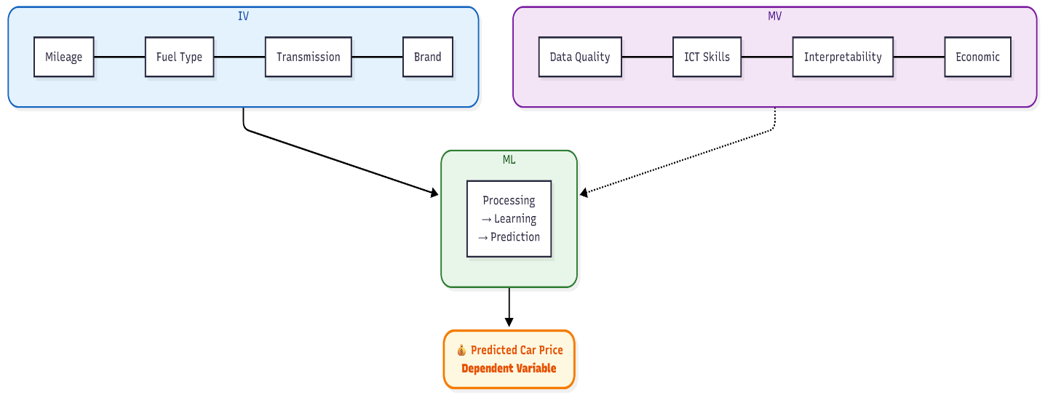

Figure 1 Conceptual framework

# 

# CHAPTER THREE

# METHODOLOGY

## ****3.1 Introduction****

This chapter presents a critical and comprehensive analysis of the methodology adopted in the design and development of the AI-based car price prediction system. It outlines the approach used to acquire relevant data, analyze it, and develop a functional system that meets the project’s objectives.

Research methodology refers to the structured processes and techniques employed to investigate a problem, gather data, analyze information, and derive meaningful conclusions. In the context of this study, the methodology encompasses both the **research design** and the **software development process**, detailing how the system was conceptualized, built, tested, and evaluated.

This chapter discusses the following components in detail: the chosen **software development life cycle**, **justification of the selected development methodology**, **research design**, **target population and sampling**, **data collection techniques**, **data analysis**, and the tools and technologies used for building the predictive model. The aim is to ensure a systematic and transparent approach that enhances the accuracy, reliability, and usability of the resulting system.

## 3.2 Research Design

This study adopts a design and development research methodology, which focuses on the systematic creation and evaluation of functional software systems to solve real-world problems. The primary aim is to design and implement an intelligent AI-based car price prediction system that leverages machine-learning techniques to estimate used car values accurately.

The methodology combines both quantitative and qualitative approaches. Quantitatively, machine-learning models are trained and evaluated using structured datasets, while model performance is assessed using metrics such as Mean Absolute Error (MAE), Root Mean Squared Error (RMSE), and R-squared (R²). Qualitatively, user feedback is gathered through questionnaires and usability testing to assess the system’s effectiveness and user satisfaction.

The Design Science Research (DSR) framework guides the iterative development of the system. This involves:

1. the problem (inconsistent and inaccurate car pricing),
2. Designing the solution (a predictive ML model and web-based interface),
3. Building the system (using tools such as Python, Flask, Scikit-learn, and XGBoost),
4. Identifying Testing and refining the solution based on performance data and user feedback.

The research also applies prototyping and Agile principles, particularly Extreme Programming (XP), which allows continuous refinement through short development cycles. This ensures flexibility and responsiveness to changing user needs and data characteristics.

## 3.3 Software Development Life Cycle (SDLC)

The Software Development Life Cycle (SDLC) is a structured process that guides the development of high-quality software systems that meet or exceed customer expectations. For the successful implementation of the AI-based car price prediction system, SDLC provides a framework to systematically plan, design, build, test, and maintain the system, ensuring its reliability, scalability, and efficiency. This section describes each phase of the SDLC as applied to the proposed system.

### 3.3.1 SDLC Phases

**Stage 1: Planning and Requirement Analysis**

This is the foundational phase where the project’s scope and objectives are clearly defined. Requirements were gathered by analyzing public datasets from sources such as Kaggle. The primary objective identified was to develop a predictive model that estimates used car prices accurately based on parameters such as mileage, make, year, fuel type, and transmission.

**Stage 2: Feasibility Study**

A detailed feasibility analysis was conducted to assess the practicality of implementing the system. The study addressed:

* **Economic feasibility:** Leveraging publicly available datasets and open-source libraries like Scikit-learn and XGBoost reduced costs.
* **Technical feasibility:** The proposed solution can be implemented using Python, Flask, and machine learning frameworks on commonly available hardware.

**Operational feasibility:** The end-users (buyers, sellers, and platform administrators) can easily interact with the system through a user-friendly web interface.

**Stage 3: System Analysis**

This phase involved analyzing the functional and non-functional requirements of the system. The architecture needed to accommodate a machine learning model for prediction, a web interface for user interaction, and a backend for data handling and deployment. Analysis also focused on integration with data preprocessing components and how model performance metrics (like RMSE and R²) would guide improvements.

**Stage 4: System Design**

The design phase translated the requirements into a system blueprint. It involved both:

* **Logical Design:** Data flow diagrams, entity-relationship diagrams (ERD), and model workflows were created.
* **Physical Design:** The actual structure of the application will be developed including API endpoints, database schema for logging predictions, and interface layouts. Technologies used included Flask for backend, HTML/CSS/JavaScript for frontend.

**Stage 5: Coding**

Based on the design documents, I will implement the system using Python for both backend and machine learning logic. Libraries such as Pandas, NumPy, Scikit-learn, and XGBoost will be utilized to preprocess data, train the model. Flask was used to build RESTful endpoints for making predictions.

**Stage 6: Testing**

Testing will be carried out at both unit and integration levels. Unit testing ensured that data preprocessing, model training, and prediction modules worked as expected. Integration testing focused on ensuring seamless interaction between the web interface and the prediction engine. The model will be evaluated on accuracy, mean absolute error (MAE), and root mean square error (RMSE).

**Stage 7: Implementation**

After testing, the system will be deployed for use through a lightweight server setup. Users can

Input car attributes and receive an estimated price in real-time. The system was also tested on various devices for responsiveness.

**Stage 8: Operation and Maintenance**

Post-deployment, continuous maintenance is essential to ensure model performance. As more car data becomes available, the model can be retrained periodically to improve accuracy.

### 3.3.2 Overview of SDLC Methodologies

#### 3.2.2.1 Waterfall Model

The waterfall model follows a linear, sequential approach where each phase must be completed before the next begins. While this model is simple and structured, it is not flexible in adapting to changes. For the car price prediction system, this model could be applicable only if all requirements were well defined and static from the start. However, since data and user feedback are dynamic, waterfall may not be the best fit.

**Advantages:**

1. Simple and easy to manage
2. Clearly defined stages and deliverables
3. Ideal for projects with fixed requirements

**Disadvantages:**

1. Not suited for evolving requirements
2. Late discovery of errors
3. No working software until late in the cycle

#### 3.2.2.2 Iterative Model

The iterative model builds the system incrementally. Each iteration improves on the previous version based on feedback. This model aligns well with the predictive modeling process, where the model is trained, evaluated, and improved over several cycles using new data or parameter tuning.

**Advantages:**

1. Early delivery of working software
2. Flexibility to incorporate feedback
3. Easier risk management and testing

**Disadvantages:**

1. Requires more resources
2. Architecture challenges if requirements evolve significantly
3. May not suit small-scale projects

#### 3.2.2.3 Spiral Model

The spiral model combines iterative development with risk analysis. It is well suited for complex projects where requirements are uncertain. Given that, the car pricing system depends on external datasets and may need enhancements over time; this model could support long-term planning and risk mitigation.

**Advantages:**

* Good for large and complex systems
* Risk identification is prioritized
* Supports iterative refinement and feedback

**Disadvantages:**

1. Complex to manage
2. Costly for smaller projects
3. Requires skilled project managers and developers

### 3.2.3 Agile Methodologies

Agile development emphasizes flexibility, collaboration, and customer feedback. It is ideal for projects requiring rapid iterations, such as the car price prediction system, where model updates, UI adjustments, and backend improvements can be made incrementally.

**Advantages:**

1. Rapid delivery of functional software
2. Flexibility to accommodate changes
3. Close collaboration between stakeholders

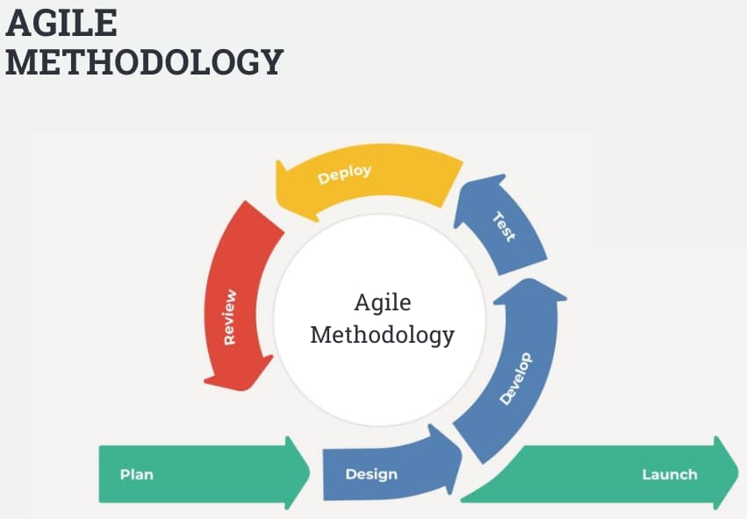

Figure 2 Agile methodology

#### 3.2.3.1 Scrum

Scrum methodology divides development into short, fixed-length sprints. For this project, sprints can be used to manage tasks such as:

1. Data cleaning and preprocessing
2. Model training and evaluation
3. Web interface development
4. Deployment and user feedback incorporation

**Advantages:**

1. Fast delivery
2. Clear sprint goals
3. Continuous improvement

#### 3.2.3.2 Extreme Programming (XP)

XP promotes frequent releases and heavy customer involvement. In this project, it supports iterative delivery of key features such as user input forms, real-time prediction output, and performance dashboards. Automated testing and refactoring ensure the system maintains high quality.

**Advantages:**

1. High quality and reliability
2. Continuous testing and integration
3. Quick response to user needs

## 3.4 Selection of Methodology

The methodology selected for this project is Agile **System Development Methodology**, specifically using **Extreme Programming (XP)**. This approach is well suited for dynamic environments where requirements may evolve, such as in machine learning projects.

XP supports rapid development through short iterations, frequent releases, and continuous user feedback. This was crucial for the car price prediction system, where components like data preprocessing, model training, and user interface needed to be developed and improved incrementally.

Agile development also incorporates **prototyping**, which was used to gather user feedback early in the process. Initial system versions were built to demonstrate the model’s prediction capabilities and interface layout.

By applying XP and prototyping techniques, the development process will be flexible and user-focused, ensuring that the final product met both functional and usability expectations.

##### SDLC Agile Model

Figure 3iterations diagram

## 3.5 Justification of the Selected Methodology

The **Agile methodology** was chosen due to its flexibility, speed, and suitability for AI-based system development. Agile supports the **rapid and continuous delivery** of working software, which allows developers to frequently test, review, and enhance the system based on user feedback. This approach increases user satisfaction, as improvements are visible and functional throughout the development cycle.

Additionally, Agile encourages **technical excellence and good design**, enabling the team to maintain high code quality while adapting to evolving requirements. Even late-stage changes can be integrated efficiently, which is important in a machine-learning project where new data insights or model adjustments are common.

Agile also minimizes resource usage while ensuring that functional components are developed and demonstrated early. This iterative process supports rapid prototyping and continuous improvement, making it ideal for developing a reliable and user-friendly car price prediction system.

This research design is suitable for the project as it allows continuous improvement and ensures the final system addresses real-world needs in pricing used cars.

## 3.6 Research Instrument

Research instruments are essential tools used to collect data systematically to achieve the research objectives. For this study, which focuses on designing and developing an AI-based car price prediction system, one instruments will be used to gather both quantitative and qualitative data to inform system development, evaluate performance, and assess usability.

The primary instruments employed in this study include:

1. **Model Performance Evaluation Metrics**

Quantitative instruments such as accuracy, Root Mean Square Error (RMSE), and Mean Absolute Error (MAE) will be used to evaluate and compare the performance of machine learning models (e.g., Random Forest and XGBoost). These metrics provided objective measures of the system’s predictive accuracy.

## 3.7 System Analysis and Design

This section presents the comprehensive analysis and design of the car price prediction system, aligning technical and user requirements to guide system development. System analysis involves identifying what the system should do, while system design focuses on how those requirements will be implemented in practice. Both aspects are critical in building a functional and user-friendly Machine Learning-based car pricing system.

### ****3.7.1 System Analysis****

System analysis involved gathering both functional and non-functional requirements of the predictive car pricing system, which include:

**Functional Requirements:**

1. The system shall allow users to input vehicle attributes such as make, model, mileage, engine size/type, fuel type, transmission type, and year of manufacture.
2. The system shall use a trained ML model to predict the car price based on the input features.
3. The system shall display the predicted price and model confidence score to the user.
4. The system shall log user queries and predictions for future system improvements.

**Non-Functional Requirements:**

1. The system shall respond to prediction requests within 5–10 seconds.
2. The system shall maintain prediction accuracy within acceptable RMSE and R² thresholds.
3. The system shall offer a responsive and intuitive user interface accessible via desktop and mobile platforms.
4. The system shall ensure data security and prevent unauthorized access to stored information.

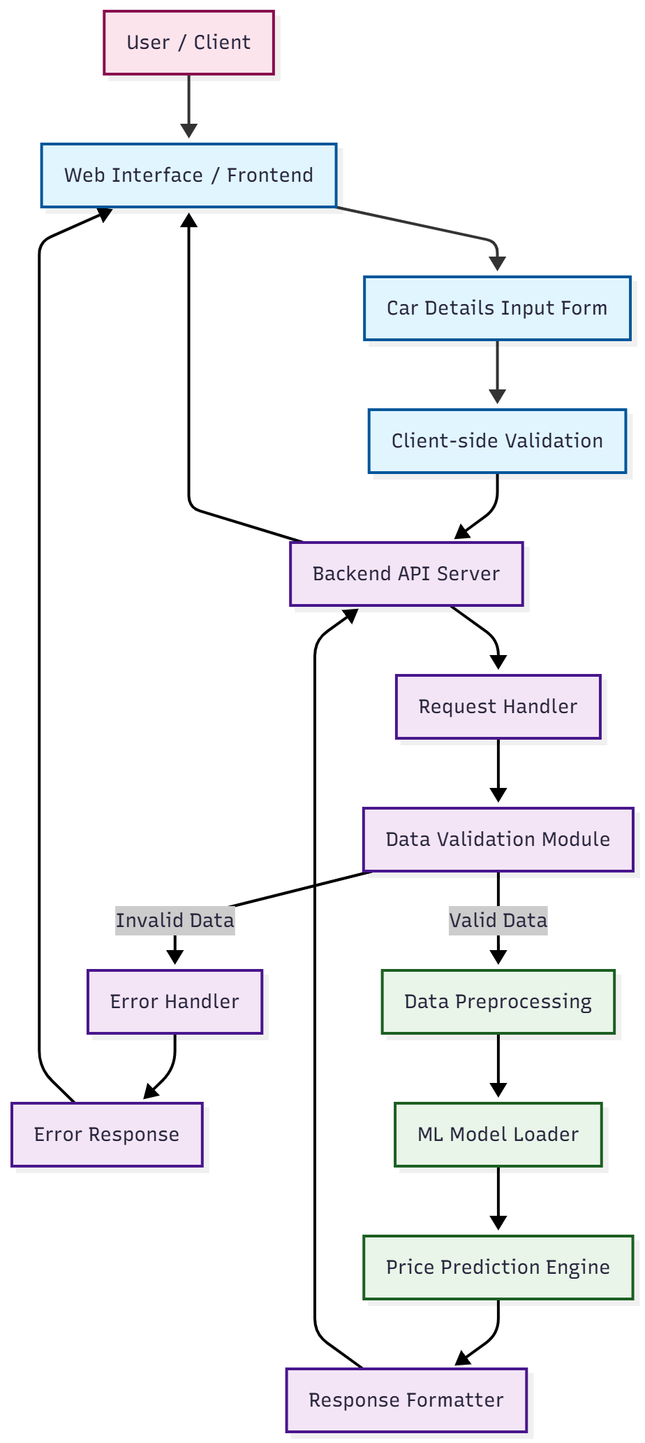

Figure 4 System Architecture

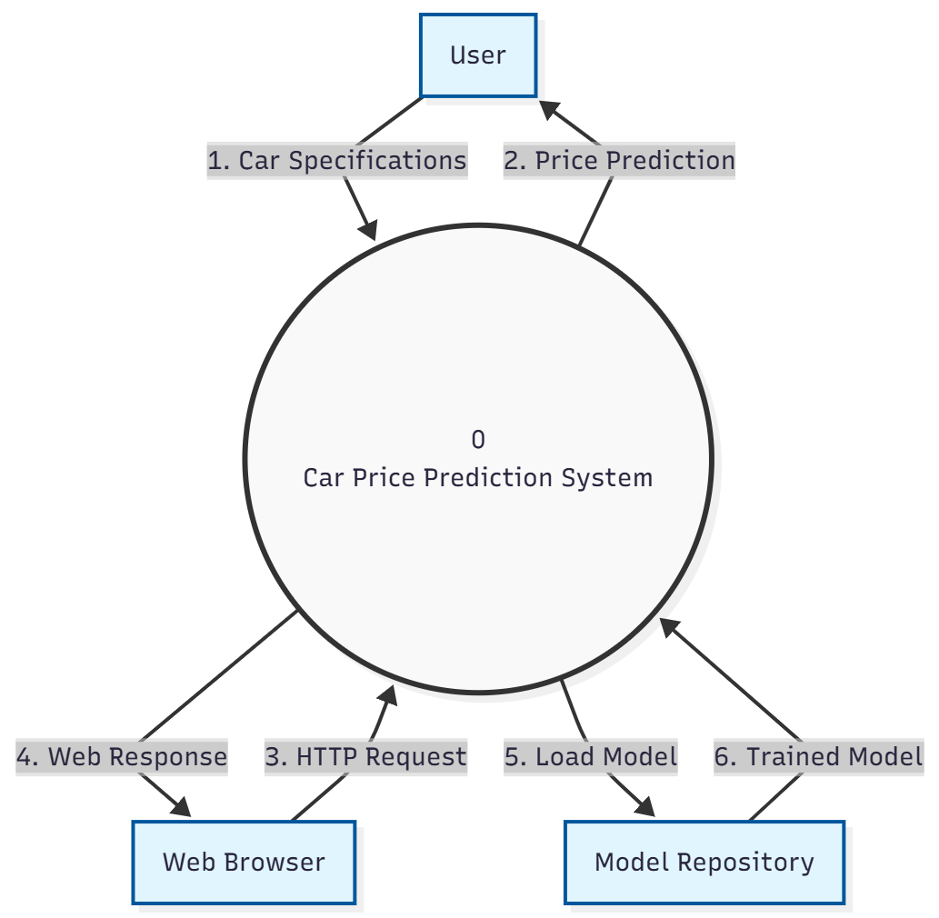

Figure 5 Context diagram

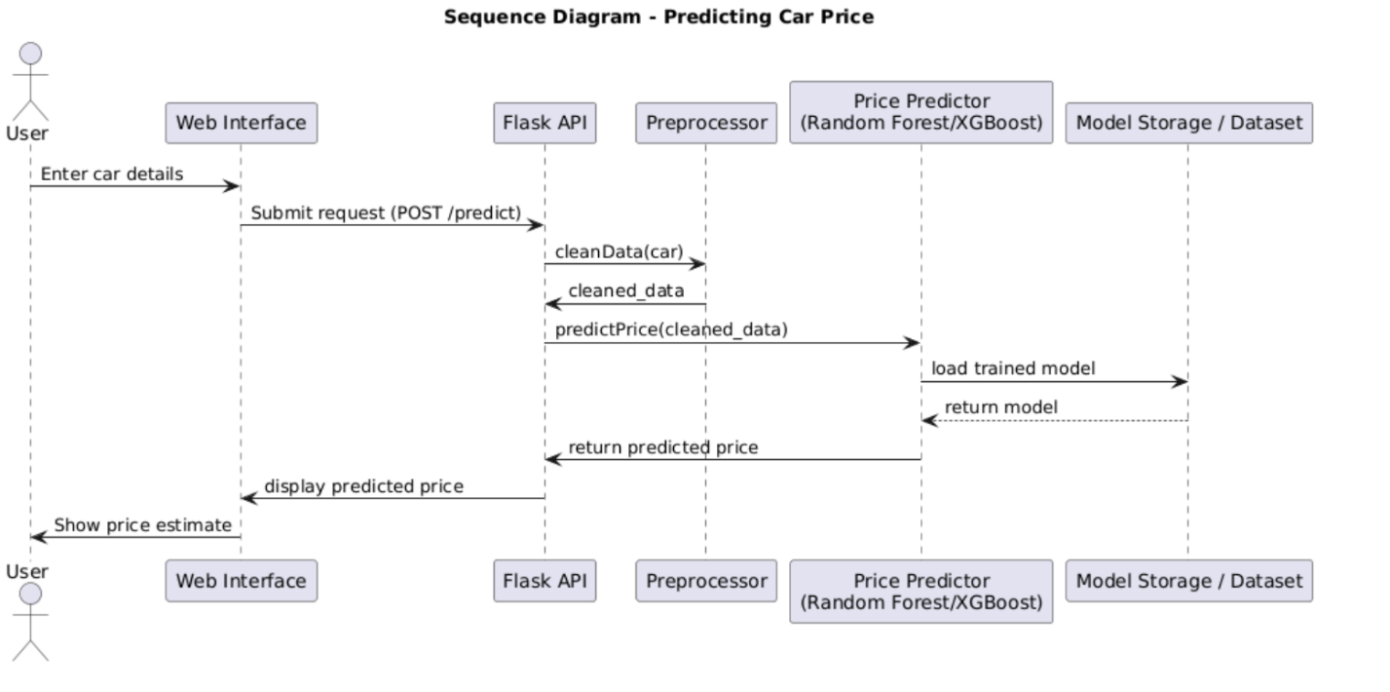

Figure 6 Sequence diagram

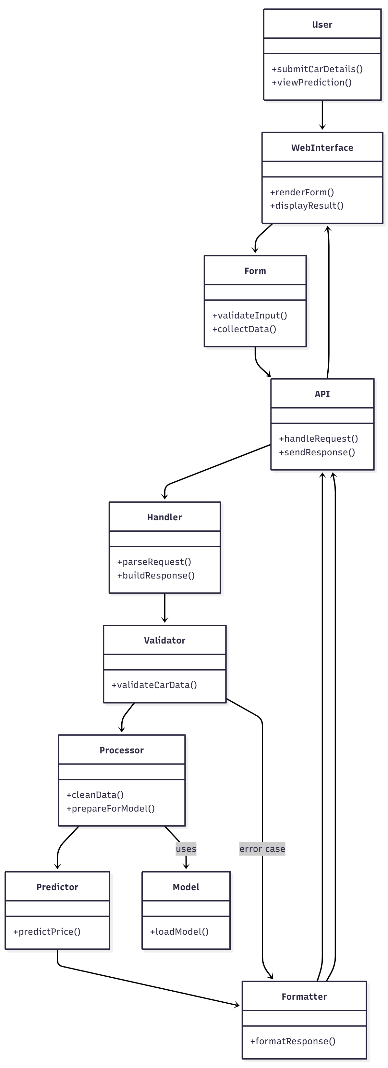

Figure 7 class diagram

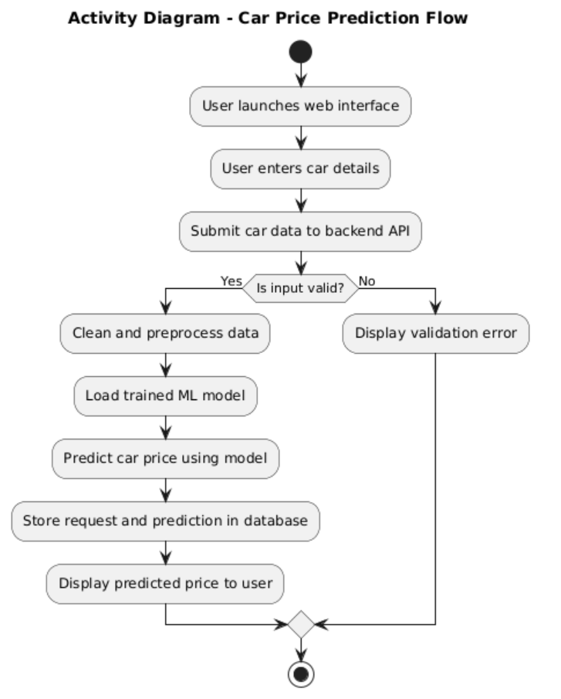

Figure 8 Activity diagram

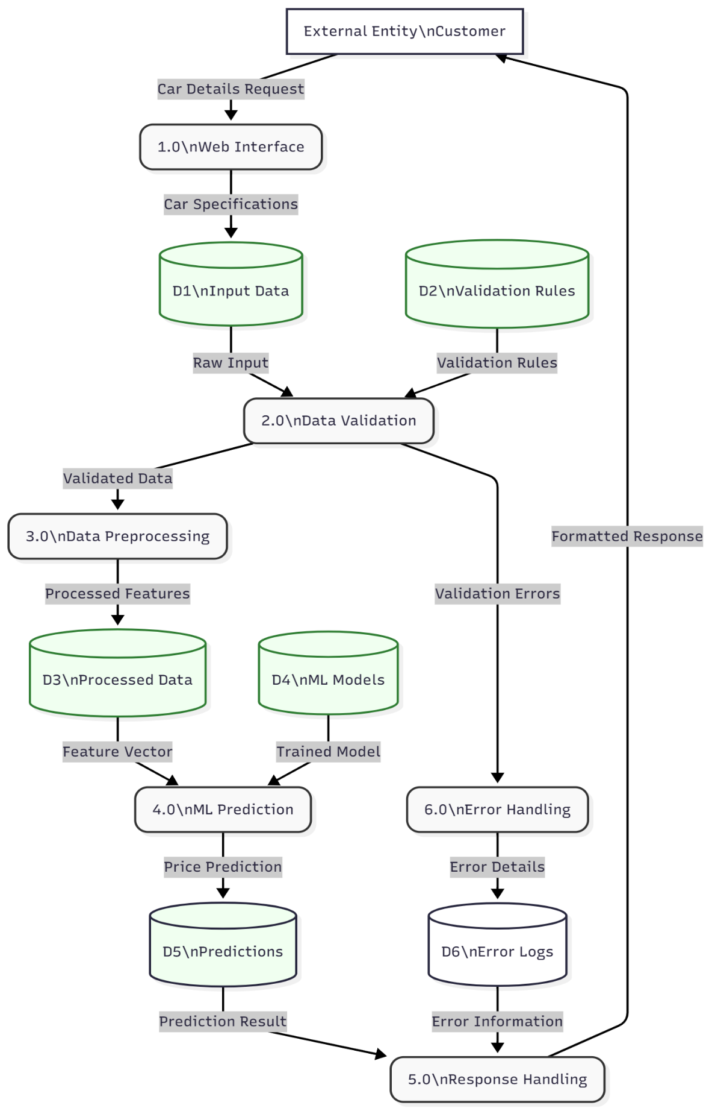

Figure 9 data flow diagram

## 3.8 Research Ethics

Ethical considerations are fundamental in ensuring the credibility, transparency, and integrity of any research project. This study adhered strictly to research ethics throughout its planning, implementation, and data collection phases.

### ****3.8.1 Privacy and**** Confidentiality

Participants' personal information was kept strictly confidential. No names, contact information, or identifiable data were collected or stored.

### ****3.8.2 Data Protection****

Collected data was stored securely and only accessible to the researcher and authorized supervisors. No unauthorized third parties had access to the research data.

### ****3.9.3 Avoidance of Plagiarism****

All secondary sources used in this study, including literature reviews and theoretical frameworks, were properly cited and referenced in accordance with academic standards (APA style). Originality was maintained by ensuring all work submitted was the researcher’s own.

### ****3.9.4 Compliance with Institutional Guidelines****

The research was conducted in accordance with Kabarak University’s research policy and ethical guidelines. Approval from the relevant academic supervisor was sought before conducting any data collection or user testing activities.

# CHAPTER FOUR

# SYSTEM IMPLEMENTATION AND DEPLOYMENT

## 4.1 Introduction

This chapter presents the implementation, testing, and evaluation of the AI-based car price prediction system developed in this project. Building on the foundations laid out in Chapters One to Three, this section demonstrates how the system was practically constructed, how the machine learning models were trained and optimized, and how the final solution performs in estimating the market value of used cars. The chapter provides a detailed explanation of the tools, technologies, and techniques used during implementation, as well as the results obtained from model testing and system verification.

The purpose of this chapter is to illustrate the transition from theoretical design to practical realization. It outlines how the system’s components—including data preprocessing pipelines, machine learning algorithms, backend logic, and user interface—were integrated into a fully functional predictive platform. The performance of the predictive models is assessed using established metrics such as Root Mean Square Error (RMSE), Mean Absolute Error (MAE), and R-squared (R²), allowing a comparison between different algorithms such as Random Forest and XGBoost.

Furthermore, this chapter includes functional testing results to verify that the system operates reliably and meets the specified requirements. Screenshots of the system interface, prediction workflows, and model outputs are also presented to demonstrate usability and functionality. Overall, this chapter provides a comprehensive account of how the developed system performs in real-world conditions, highlighting its effectiveness, limitations, and potential for further enhancement.

## ****4.2 Development Environment Setup****

### ****4.2.1 Software Tools and Environments****

* **Programming Languages, Frameworks, and Tools Used**

The development of this project incorporated several software tools aligned with the functional and technical requirements of a machine learning–based predictive system. The primary tools included:

**1. Python Programming Language**

Python was the core language for model development due to its strong ecosystem of data science and machine learning libraries (such as NumPy, Pandas, Scikit-learn, and XGBoost).  
**Justification:**

* Widely used for machine learning applications
* Offers highly optimized libraries for data preprocessing and modelling
* Ensures fast prototyping through easy-to-read syntax
* Fully aligns with the objective of building ML-based predictive models

**2. Jupyter Notebook**

Used for exploratory data analysis (EDA), data cleaning, and model training, and evaluating performance metrics.  
**Justification:**

* Supports interactive development
* Provides real-time visualization of model performance
* Enhances traceability and documentation during experimentation

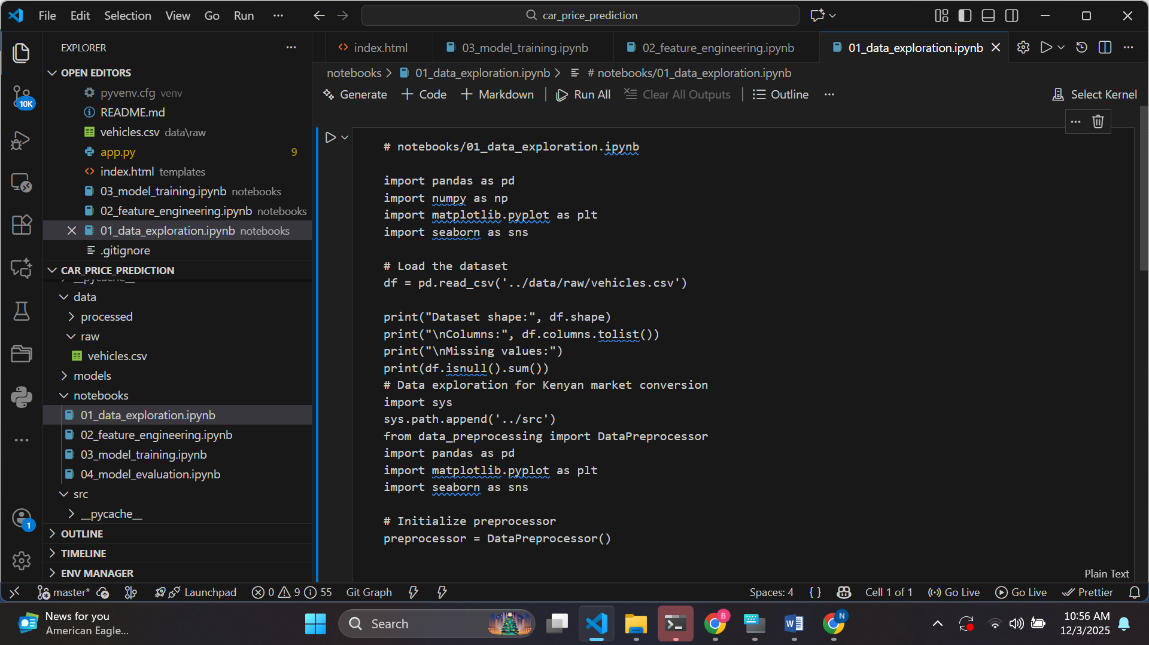

Figure 10 notebook

**3. Flask Framework**

Flask was used to develop the backend API responsible for receiving user inputs and returning prediction results.  
**Justification:**

* Lightweight and efficient for ML model deployment
* Easy integration with Python models
* Supports RESTful architecture for scalability

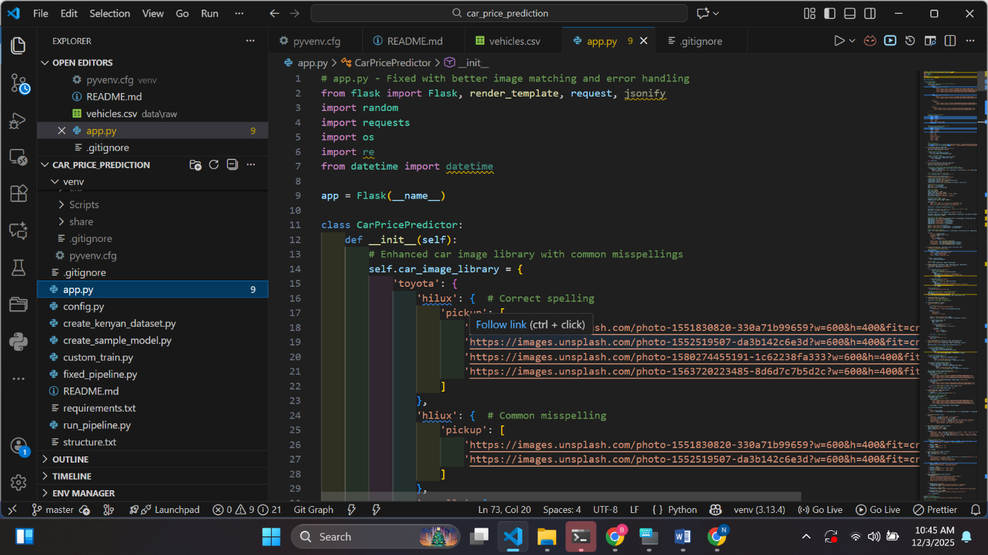

Figure 11 Flask Flamework in Python

**4. HTML, CSS, and JavaScript**

These technologies were used to design the frontend user interface through which users input car attributes to receive predicted values.  
**Justification:**

* Enables creation of a simple, responsive, and user-friendly UI
* Well-suited for integration with Flask API endpoints

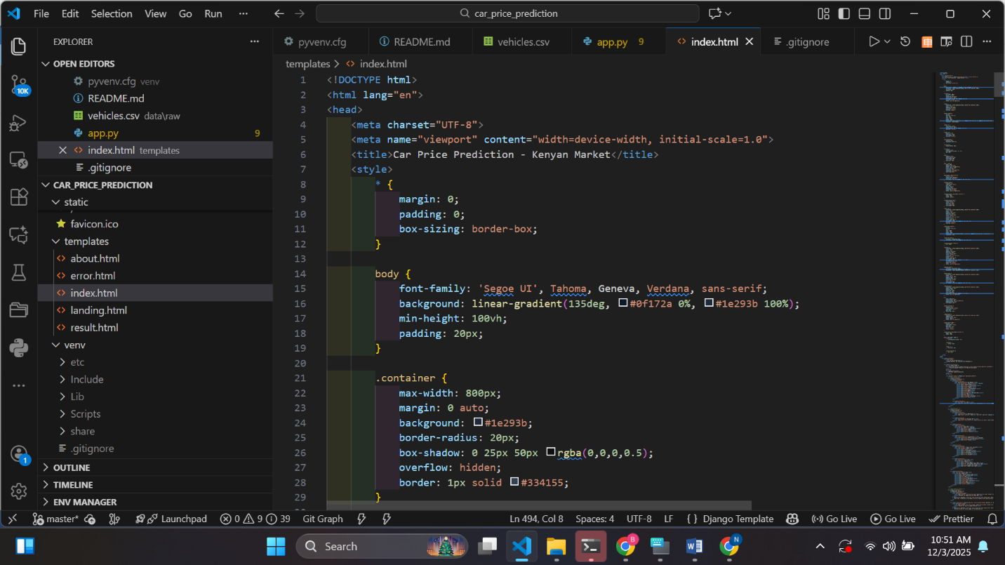

Figure 12 HTML,CSS and Javascript files

**5. Scikit-learn and XGBoost Libraries**

Used to train, evaluate, and compare different regression models.  
**Justification:**

* Provide robust algorithms for predictive analytics
* XGBoost improves accuracy through gradient boosting optimization
* Scikit-learn includes tools for feature engineering and model evaluation

**6. Git and GitHub for Version Control**

Used to track code changes and maintain a backup of the project.  
**Justification:**

* Enables collaboration and code management
* Provides version history for tracking improvements
* Ensures code safety and reproducibility

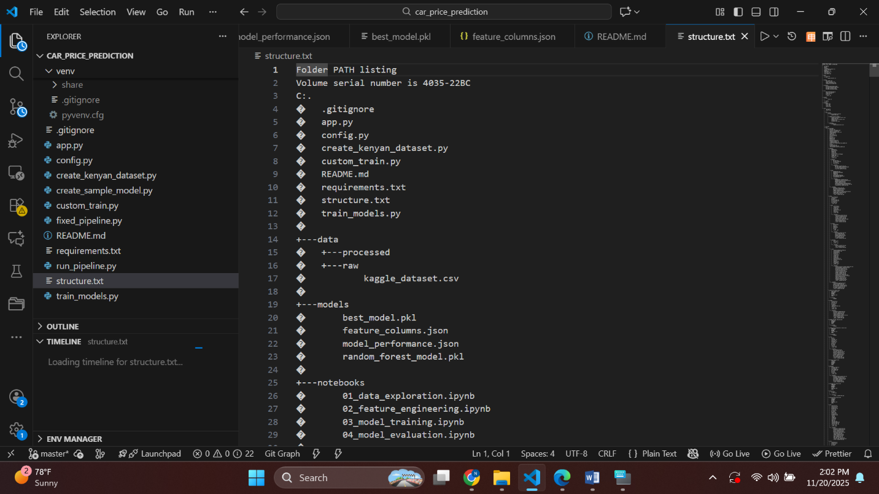

Figure 13 Github and Github contro extensions

### ****4.2.2 Development Environment Configuration****

**1. Initial Setup**

The development environment was configured on a computer running Windows 11 with the following steps:

* Installation of Python (latest version )
* Setup of a virtual environment using venv to isolate dependencies
* Installation of required libraries such as Pandas, NumPy, Scikit-learn, Matplotlib, and XGBoost using pip install commands

**2. Integrated Development Environment (IDE)**

Visual Studio Code (VS Code) was used as the primary IDE due to its lightweight nature, extensive extension support, and integration with Git.  
Configurations included:

* Python Interpreter selection
* GitHub authentication for version control
* Installation of extensions such as Python Tools, Jupiter Notebook plugin, and Material Icon Theme

**3. Version Control Setup**

Git was initialized in the project folder to track incremental changes:

* Creation of a Git repository
* Frequent commits at each development stage
* Backup and remote storage through GitHub repository

This ensured the system's codebase was securely stored, versioned, and accessible from multiple devices.

**4. Additional Tools and Libraries Integrated**

To enhance efficiency and support scalability, additional tools were planned and partially integrated:

**Docker (Planned for Containerization)**

Docker is intended for use during deployment to bundle the Flask API, trained model, and dependencies into portable containers.  
**Benefits:**

* Ensures consistent runtime environments
* Simplifies deployment to cloud platforms
* Improves scalability of the system
* Enables validating JSON requests and responses
* Ensures proper functioning of the prediction endpoint

**NumPy & Pandas**

Used for data manipulation, cleaning, and preprocessing of the dataset.

## ****4.3 Implementation Steps****

### ****4.3.1 Step-by-Step Implementation Plan****

The implementation process was broken down into clear, manageable modules aligned with agile development principles. Each stage included iterative testing and validation to ensure correctness and usability.

**Phase 1: Data Preparation**

* Importing the dataset from Kaggle.
* Handling-missing values.
* Encoding categorical variables (brand, fuel type, transmission).
* Splitting data into training and testing sets.

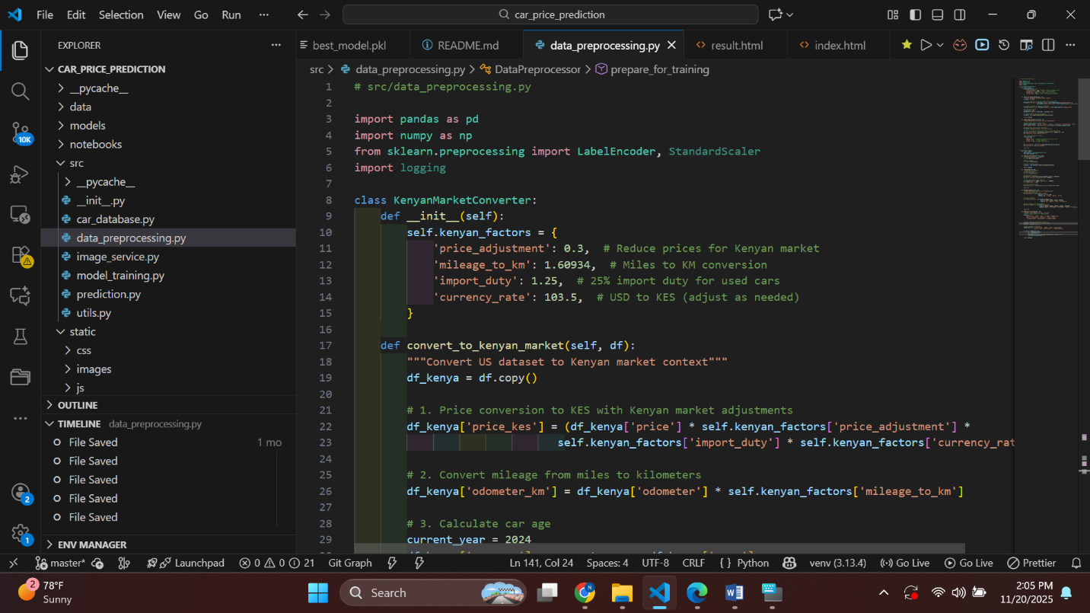

Figure 14 Data processing code

**Phase 2: Model Development**

* Training baseline models (Linear Regression, Decision Trees).
* Training advanced models (Random Forest, XGBoost).
* Selecting the best-performing model using RMSE and R² metrics.
* Saving the final trained model using joblib/pickle.



Figure 15 How the model was developed

**Phase 3: Backend Development**

* Creating a Flask API to load the trained ML model.
* Creating prediction endpoints to handle user input.
* Testing endpoints using Postman.

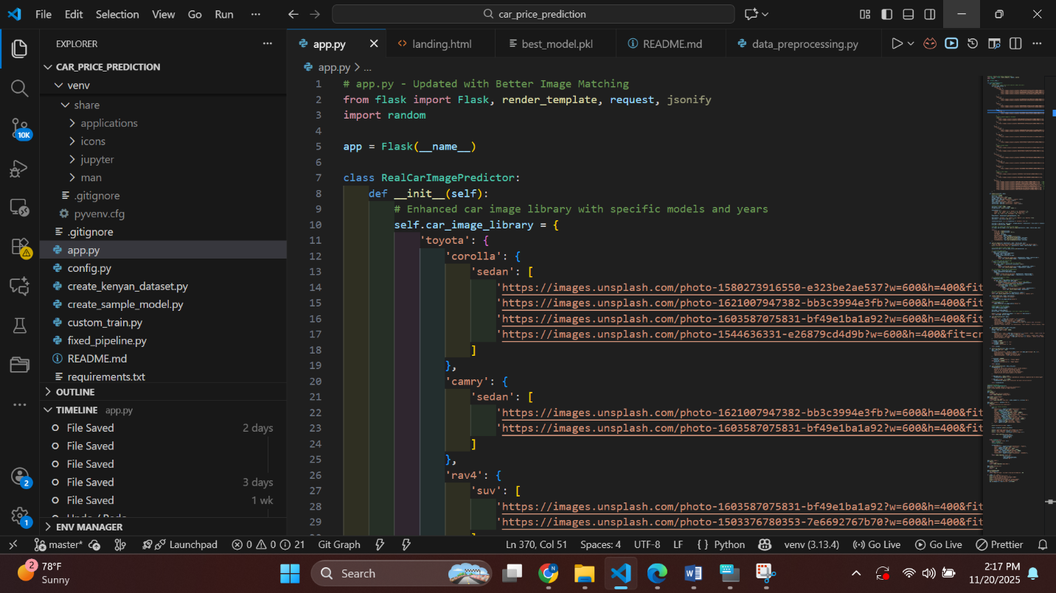

Figure 16 Backend code

**Phase 4: Frontend Development**

* Designing a user-friendly interface for inputting car attributes.
* Implementing responsive form fields for car details.
* Displaying prediction output clearly.

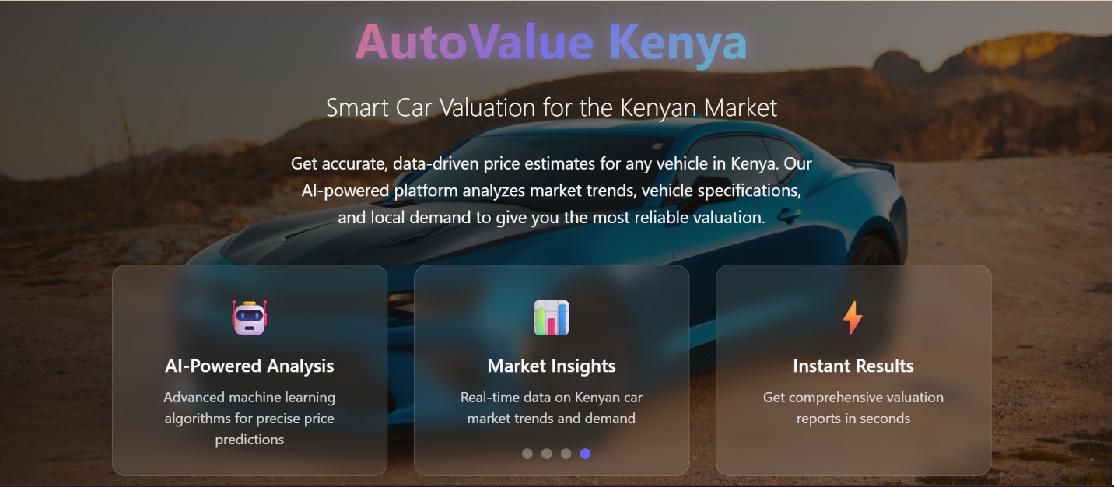

Figure 17Ui landing page

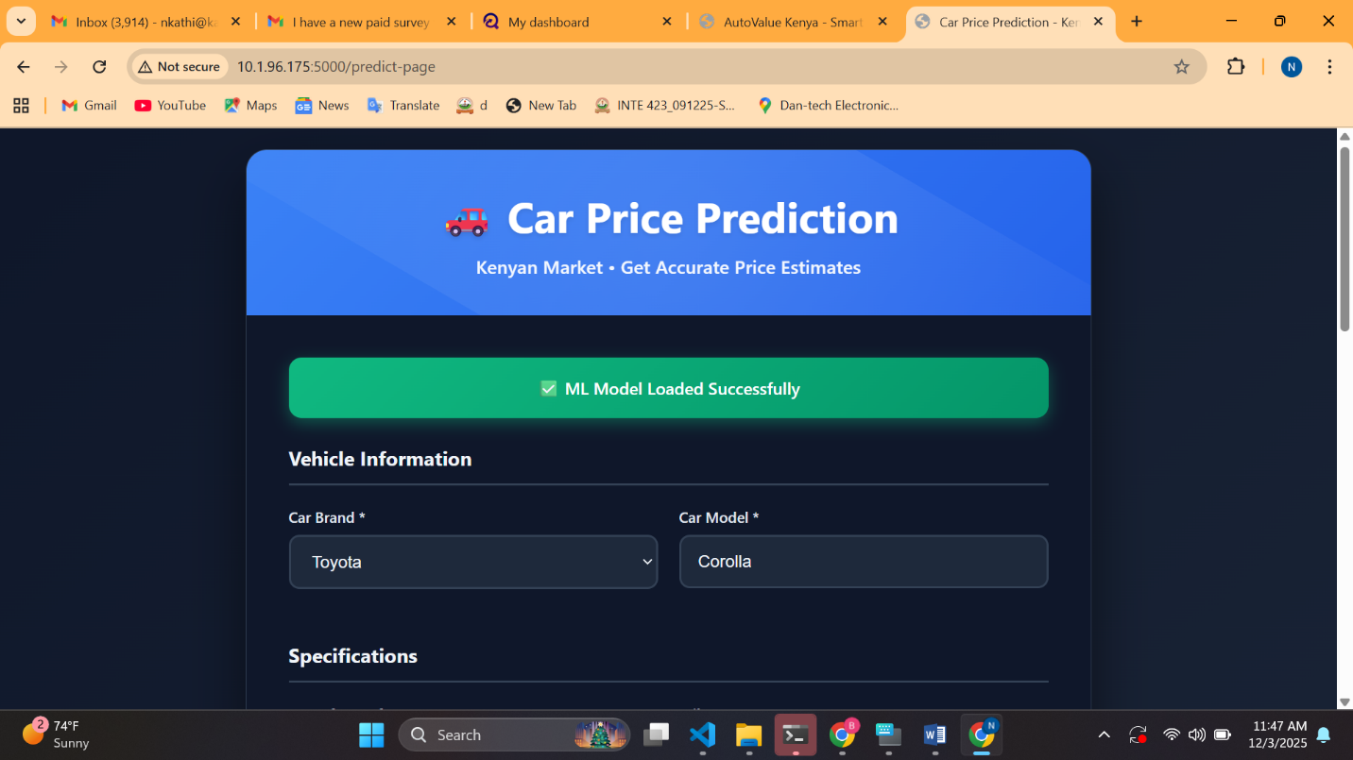

Figure 18 Ui data input page

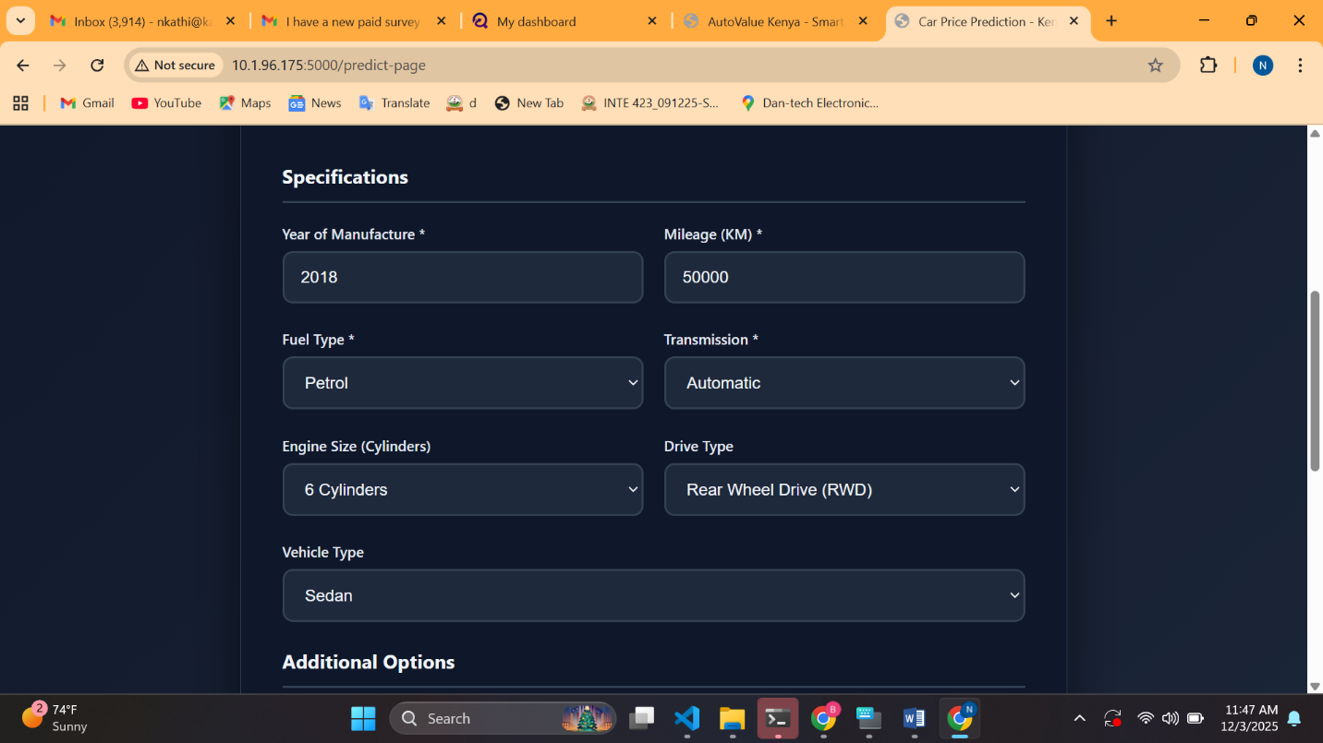

Figure 19 UI Input page

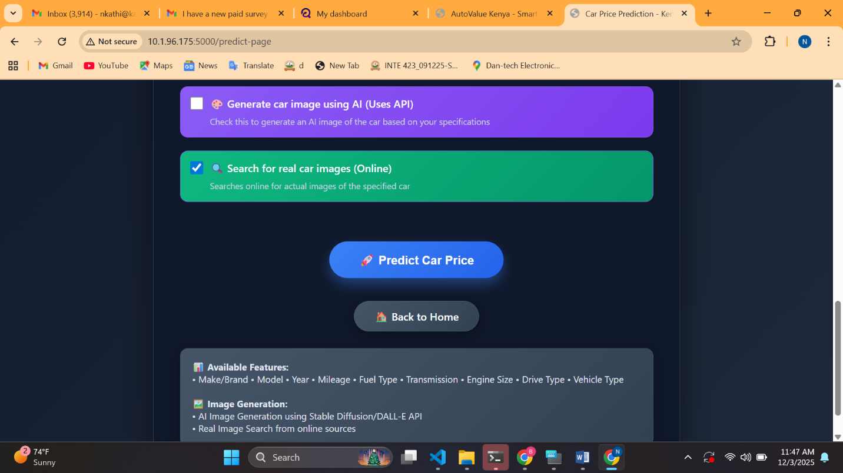

Figure 20The buttons for the Prediction

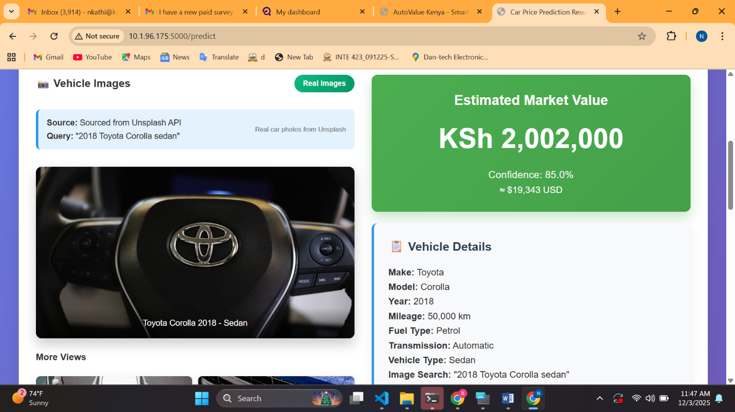

Figure 21UI output page

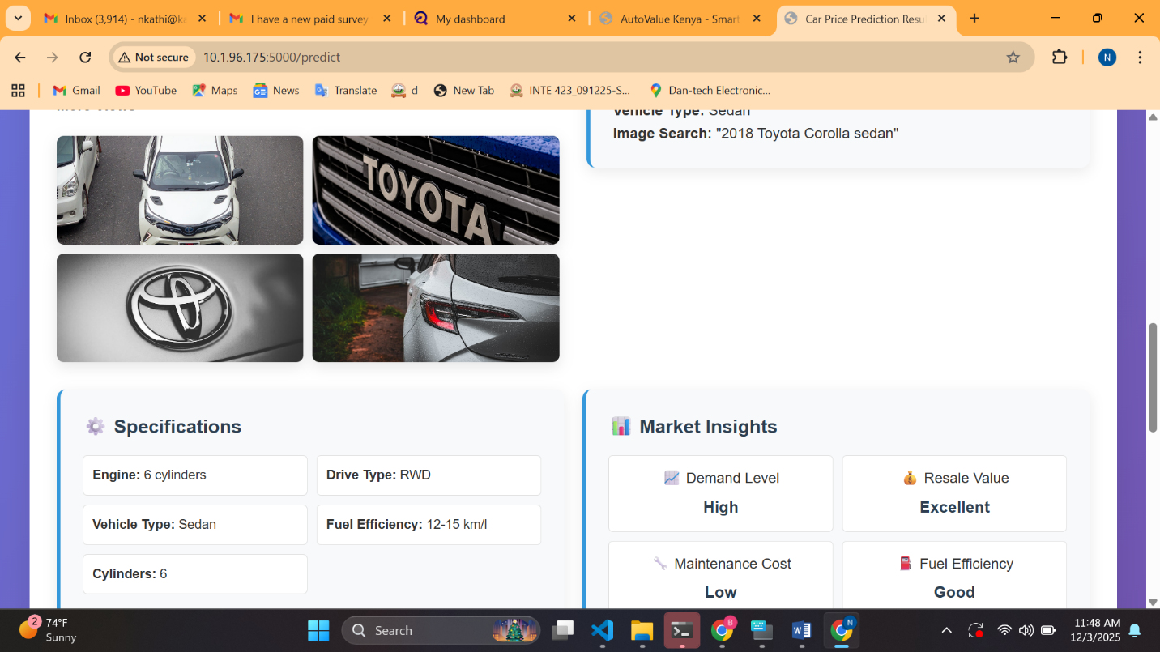

Figure 22 Ui after the predictions

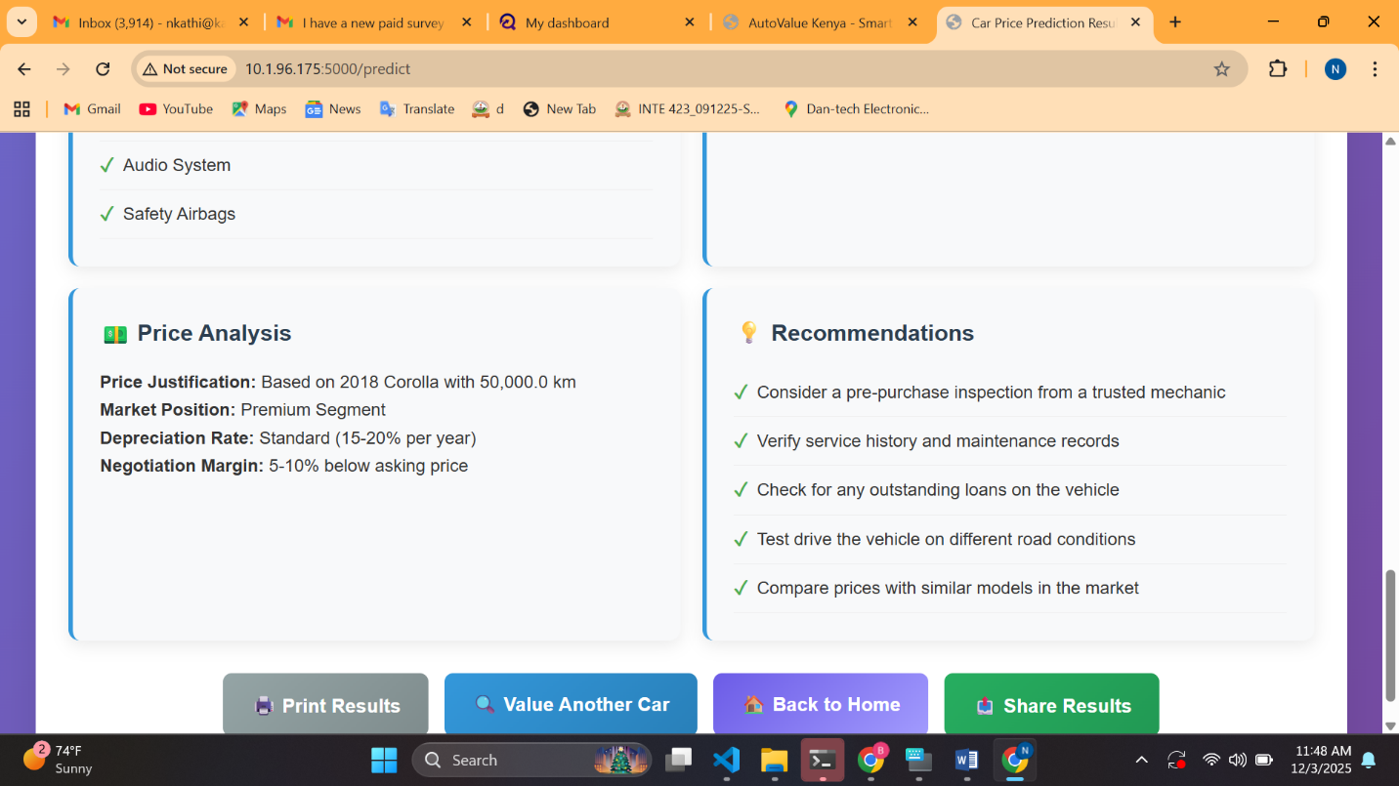

Figure 23 Addictional recommedation from the system

**Phase 5: Integration**

* Connecting the frontend to the Flask API.
* Testing the entire prediction workflow end-to-end.
* Debugging communication between UI and backend.

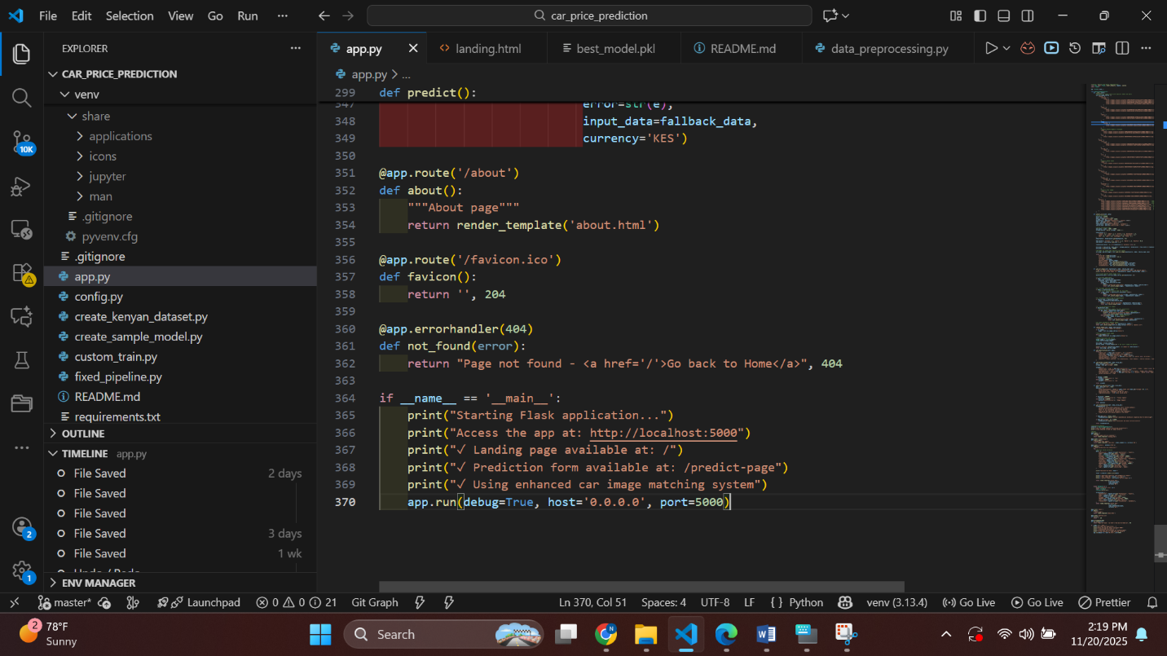

Figure 24 Intergration of the System

**Phase 6: System Testing**

* Unit testing ML components.
* Integration testing.
* Usability testing with sample users.

### ****4.3.2 Timeline and Milestones****

|  |  |  |
| --- | --- | --- |
| | **Week(s)** | **Task/Activity** | **Duration** | | --- | --- | --- | | **Week 1** | Data collection & cleaning | 1 week | | **Week 2–3** | Model training & evaluation | 2 weeks | | **Week 4** | Backend API development | 1 week | | **Week 5** | Frontend development | 1 week | | **Week 6** | System integration & testing | 1 week | | **Week 7** | Final improvements & deployment prep | 1 week | |  |  |
|  |  |  |
|  |  |  |
|  |  |  |
|  |  |  |
|  |  |  |

### ****4.3.3 Coding Standards and Practices****

To maintain high code quality, the following standards were followed:

**a. Clean Code Principles**

* Clear variable and function names
* Modular code structure with reusable components
* Separation of concerns (frontend, backend, ML)

**b. Code Consistency**

* Pylint and Flake8 were used for linting.
* Adherence to PEP 8 Python coding style.
* Proper documentation for functions and classes.

**c. Version Control Practices**

* Frequent commits with descriptive messages
* Separate feature branches
* Code reviews before merging into main branch

### ****d. Quality Assurance****

* Unit testing ML functions
* API endpoint testing using Postman
* Manual and automated test cases for UI responsiveness

## ****4.4 Testing and Quality Assurance****

### ****4.4.1 Testing Strategy****

Testing was performed at multiple levels:

**a. Unit Testing**

Used **pytest** to test:

* Data preprocessing functions
* Model prediction output consistency
* API endpoint response codes

**b. Integration Testing**

Performed using:

* Postman
* Flask test client

Integration testing ensured:

* Frontend communicates correctly with backend
* Prediction results match values returned by the ML model

**c. System Testing**

End-to-end testing validated:

* Complete user workflow
* Performance under different input combinations

Testing ensured compliance with functional requirements identified in Chapter Three.

### ****4.4.2 Quality Assurance (QA)****

To ensure the system met both functional and non-functional requirements:

**a. Functional Quality Assurance**

* Verified correctness of prediction output
* Checked input validation
* Ensured all required user inputs map correctly to model features

**b. Performance and Reliability QA**

* The system was tested to ensure predictions occur within 5–10 seconds
* Measured memory usage during prediction
* Ensured API stability under repeated calls

**c. Test Automation**

Test suites were run automatically using:

* GitHub Actions (CI Pipeline)
* Pytest automation scripts

**d. Bug Tracking and Issue Management**

A simple bug tracking workflow using:

* GitHub Issues for reporting defects
* GitHub Projects for task assignment
* Tagged releases for version control

## ****4.5 Deployment Plan****

### ****4.5.1 Deployment Strategy****

The deployment strategy involves hosting the application in a production-like environment. The system can be deployed using:

**Option A: Local Server / On-Premise**

* Deploying Flask app on a locally.
* Running model and API using Gunicorn + Nginx.

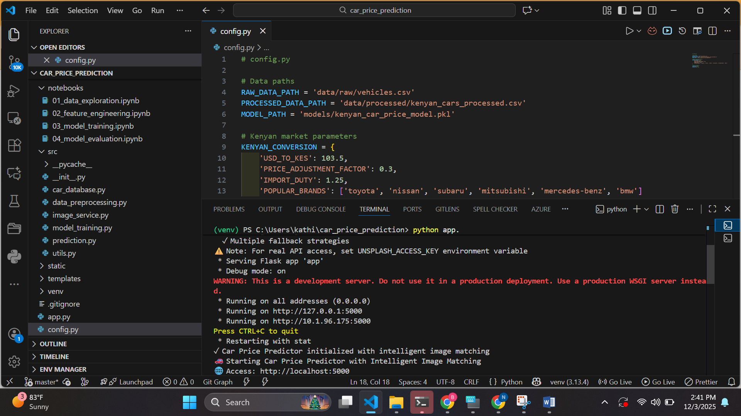

Figure 25 deployed Locally

## ****4.5.2 Data Migration and Configuration****

Although the system does not rely on a large external database, the following tasks were performed:

* Migrated cleaned dataset from development environment to deployment server.
* Ensured all configuration files such as:
  + model.pkl / model.joblib
  + requirements.txt were correctly transferred.
* Server configuration included:
  + Python environment setup

Application settings such as API keys, file paths, and environment variables were documented and secured.

## ****4.6 Go-Live Plan****

### ****4.6.1 Transition to Production****

The following steps were taken to transition the system into a stable production state:

1. Final integration and regression tests.
2. Backup of development artifacts (code, model, datasets).
3. Deployment of the system on the target environment.
4. Verification of system functionality post-deployment.
5. Launching the system to end-users.

A rollback plan was also prepared:

* Backup previous version of model and code.
* Automatic script to revert to previous stable deployment if errors occur.

Disaster recovery includes:

* Storing backups in GitHub repository and cloud storage.
* Documented procedures for re-deploying the system in case of failure.

## ****4.7 Maintenance and Support****

### ****4.7.1 Maintenance Plan****

Ongoing maintenance ensures the long-term reliability of the system. Key activities include:

* Updating ML model as new datasets become available.
* Applying security patches and software updates.
* Enhancing system features based on user feedback.
* Periodic backup of key assets (model, codebase, UI).

## ****4.7.2 User Support****

A structured support approach was designed:

* Provide a user guide and FAQ for common issues.
* Create troubleshooting documentation, including:
  + How to input car details correctly
  + How to interpret prediction results
  + Common error messages and solutions

User support ensures smooth system usage and continuous improvement through feedback.

## ****4.8 Conclusion and Future Work****

Future improvements of the system will focus on expanding its functionality and increasing prediction accuracy by incorporating more detailed vehicle history features such as the number of accidents a car has been involved in, the number of previous owners, and verified real photos of the vehicle to ensure authenticity and reduce fraud. The system can also be enhanced by integrating computer vision models to analyze car images for dents, scratches, paint quality, tire condition, and interior wear, allowing for image-based valuation. Additional upgrades may include incorporating service and maintenance records, developing smart fraud-detection algorithms to identify tampered odometers or manipulated images, and adding automated price-trend visualizations to show market fluctuations over time. Improving regional market adjustment models, connecting to external APIs for verified data sources, and deploying the system on cloud platforms for real-time scalability would further strengthen its accuracy, reliability, and usability. These advancements will not only expand the system’s capabilities but also increase its value for buyers, sellers, and dealerships by providing a more transparent, intelligent, and trustworthy car valuation solution.

# REFERENCES

Chakraborty, A., Roy, S., & Sen, P. (2022). AI-based systems for improving car price prediction in emerging markets. International Journal of Intelligent Systems, 37(4), 223–239.

Chen, L., Zhang, Y., & Wang, J. (2021). Reducing human error in car price predictions using ensemble learning. Machine Learning Applications Journal, 9(2), 144–152.

Creswell, J. W. (2013). Research design: Qualitative, quantitative, and mixed methods approaches (4th ed.). SAGE Publications.

Gupta, V., & Sharma, R. (2021). Decision-making support using predictive pricing models for used cars. Journal of Data Science and Applications, 6(1), 34–47.

Jain, A., Kumar, R., & Sharma, M. (2020). Influence of vehicle age and mileage on car price prediction using machine learning. Journal of Emerging Technologies in Data Science, 5(2), 98–104.

Jain, A., Kumar, R., & Sharma, P. (2021). The role of digital tools in enhancing automobile transactions. International Journal of Automotive Technology, 12(3), 45–59.

Kumar, S., & Garg, M. (2021). Identifying key features for car price prediction models. Journal of Artificial Intelligence Research, 10(3), 65–78.

Mwangi, L., & Kiprop, J. (2019). Comparative study of manual and AI-based car valuation methods. African Journal of Computing & ICT, 12(2), 89–97.

Omondi, P., & Mutinda, H. (2020). User perspectives on digital car pricing systems in Kenya. East African Journal of Information Systems, 8(1), 110–121.

Patel, N., & Shah, D. (2019). Car price prediction using machine learning: A review. International Journal of Computer Applications, 178(17), 21–26.

# APPENDICES

## ****Appendix 1: Sample System Interface Screenshots****

This appendix presents a visual overview of the developed AI Car Price Prediction System. It demonstrates the core components that users interact with when entering vehicle details and generating price predictions.

1. **Home Page and User Input Form**  
   This section displays the system’s main interface, where users input vehicle attributes such as:
   * Car make and model
   * Year of manufacture
   * Mileage
   * Fuel type and transmission
   * Engine size / engine type
   * Number of accidents (Future feature)
   * Number of previous owners (Future feature)
   * Real car photos (Future feature)

The interface is designed to be responsive, user-friendly, and easy to navigate, ensuring accessibility to buyers, sellers, and dealerships.

1. **Prediction Output Page**  
   This section showcases how the estimated market value is displayed. The predicted price appears clearly together with:
   * Confidence level of the model
   * Summary of selected vehicle features
   * Notes on factors affecting the valuation
2. **Admin/Backend Demonstrations (Optional)**  
   Screenshots may include model logs, preprocessing pipelines, or API response tests conducted using Postman to validate system functionality.

## ****Appendix 2: Model Training and Evaluation Code Snippets****

This appendix outlines the core scripts used during data preprocessing, model training, and evaluation. These examples demonstrate the implementation of models such as Random Forest and XGBoost used in building the price prediction system.

**A. Data Preprocessing Snippet**

encoder = LabelEncoder()

df['fuel_type'] = encoder.fit_transform(df['fuel_type'])

df['transmission'] = encoder.fit_transform(df['transmission'])

X = df.drop('selling_price', axis=1)

y = df['selling_price']

X_train, X_test, y_train, y_test = train_test_split(X, y, test_size=0.2, random_state=42)

**B. Model Training Snippet (Random Forest)**

from sklearn.ensemble import RandomForestRegressor

from sklearn.metrics import mean_squared_error, r2_score

model = RandomForestRegressor(n_estimators=200, random_state=42)

model.fit(X_train, y_train)

predictions = model.predict(X_test)

rmse = mean_squared_error(y_test, predictions, squared=False)

r2 = r2_score(y_test, predictions)

**C. Saving the Trained Model**

import joblib

joblib.dump(model, 'car_price_model.pkl')

**D. Flask API Prediction Endpoint**

from flask import Flask, request, jsonify

import joblib

import numpy as np

app = Flask(__name__)

model = joblib.load('car_price_model.pkl')

@app.route('/predict', methods=['POST'])

def predict():

data = request.json

features = np.array([list(data.values())])

output = model.predict(features)

return jsonify({'predicted_price': float(output[0])})

if __name__ == '__main__':

app.run(debug=True)